* Connecting cables
  + Macbook
    - Game pad: plug in on left side (doesn’t work through USB hub)
    - Cable to USB hub (on table where subject sits)
    - Cable to IO gear hub (on table with Macbook)
    - 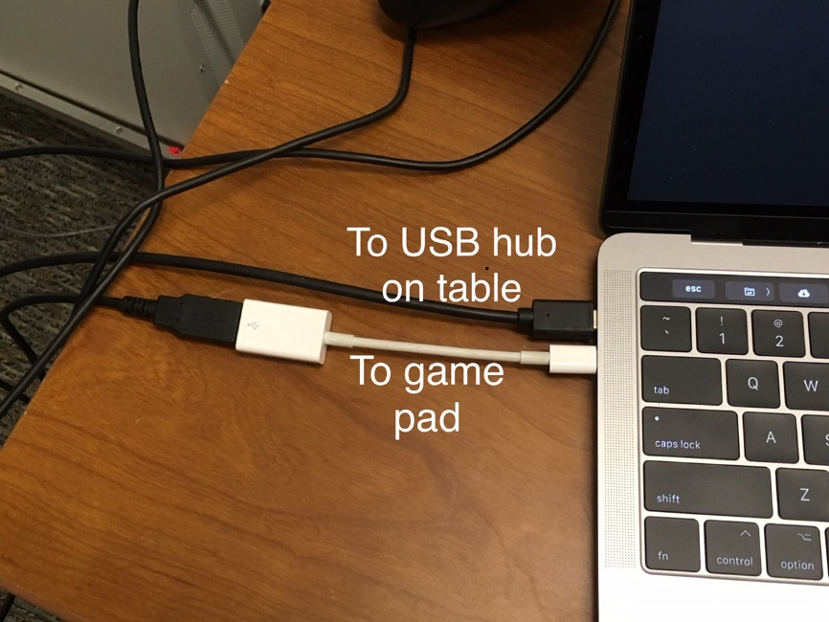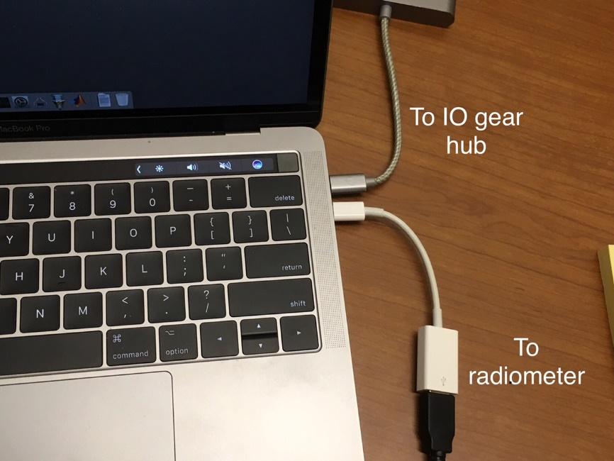Cable to PR670

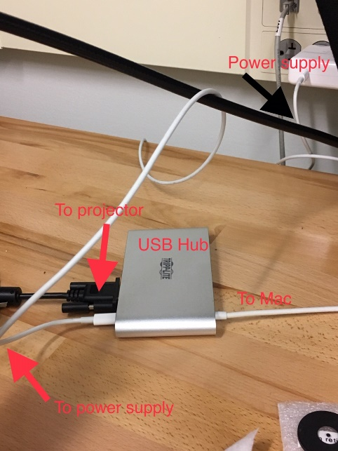

* + USB hub on desk where subject sits
    - Cable to projector
    - Cable to macbook
    - Power cord to wall (macbook adapter)
  + 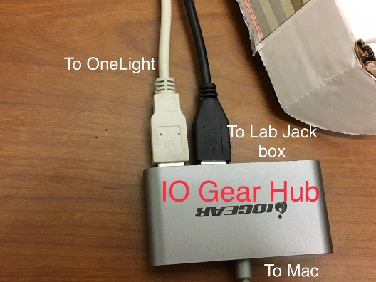IO gear hub on table with Macbook
    - Gray cord connected to OneLight
    - Cable to lab jack (red box attached to thermometer)
    - Cable to macbook

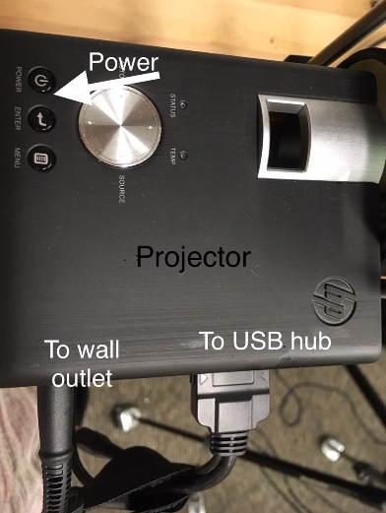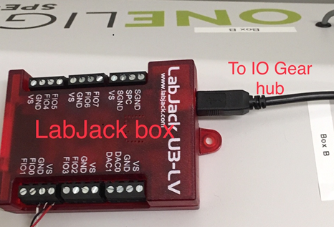

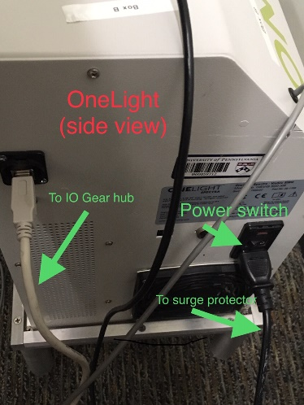

* + OneLight
    - Power cable to surge protector on floor
    - Gray cord to IO gear hub

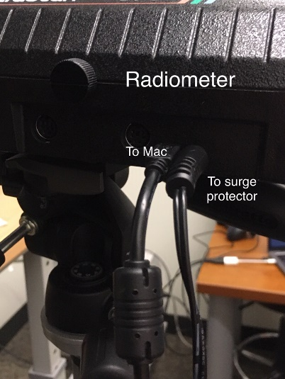

* + PR670
    - Power cable to surge protector on floor
    - Cable to macbook
* Setup routine
  + Turn on OneLight with switch
    - Should hear fan and then bulb, later see light turning on
    - 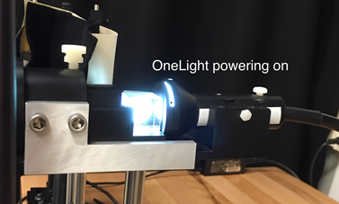if light does not turn on, this indicates a problem with the OneLight
      * The first line of defense is to wait a few seconds and try again. Sometimes it comes on after a few clicks, so wait a bit after turning on before trying again. If there are recurring problems getting the bulb to light, it may indicate that it is nearing time to replace the bulb. If this starts happening with any regularity, let David and Geoff know.
  + Turn on projector with power button (on top of device)
  + 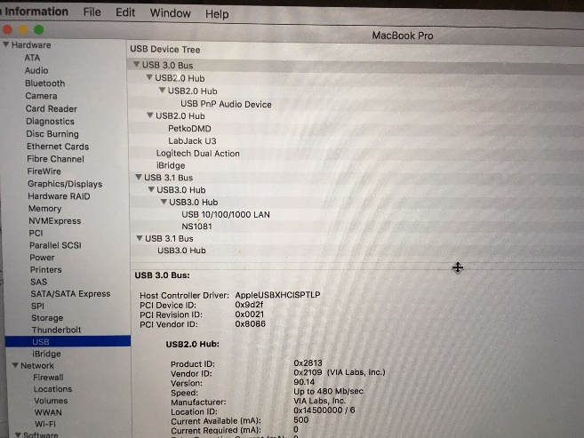Turn on computer
    - Close everything
    - Check which cables are attached
      * Apple menu🡪 about this Mac 🡪 system report 🡪 USB
      * PetkoDMD: OneLight
      * LabJackU3
      * Logitech dual action: game pad
  + Plug in power cord of radiometer, then turn on. Once the user screen comes up, plug into the computer
    - Should unplug the USB and power cord of the radiometer before you start turning other stuff on
    - Refresh system info page (command r) to see if the computer detected the radiometer. Should see “communication device” in USB
  + Turn on Matlab
    - Use 2017a
    - tbUseProject(‘OLApproach_Psychophysics’)
    - getHardware() -> routine to connect to all devices. This sets up appropriate control variables in the workspace (e.g. oneLight)
    - to check if it’s working: oneLight.SetAll (true) or (false)🡪 should see all bright or all dark.
* Shutdown routine
  + oneLight.shutdown
    - this turns off the bulb, but fan stays on for a while
    - don’t turn off OneLight or close Matlab while the fan is still running
    - when fan stops, flip switch to turn off OneLight
    - If you need to manually shut down (e.g. not connected to Matlab)—turn switch off and then back on. Normally, this doesn’t restart the bulb
    - If you haven’t yet created the object, or you lost it, you would need to do oneLight = OneLight and then oneLight.shutdown
  + radiometer.shutDown
    - this should take the radiometer back to the main menu screen.
    - Power off radiometer
    - Unplug radiometer
  + projector: press the power button twice to turn off
  + normally don’t shut down laptop—just close lid
* general setup: OneLight🡪 beam splitter🡪 reticule🡪 diffraction🡪 focusing apparatus
* Eyepiece and focusing
  + Clean eyepiece with alcohol wipes in cabinet
  + Occasionally (before subject comes) wipe the lens with anti-fog cleaner and a microfiber towel
  + Twist focusing apparatus back and forth to bring the image into focus
* switching reticules
  + for subjects, use reticule with macular blocker. For calibration/testing, use reticule without
  + 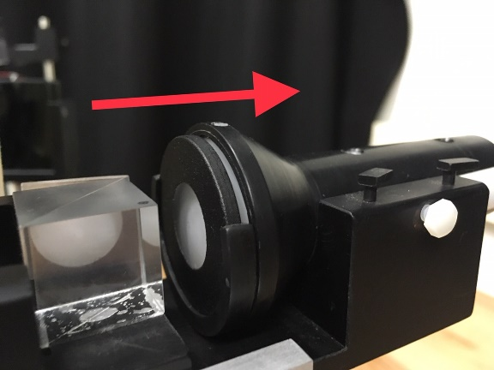unscrew small white screw near back of eyepiece setup. Then can pull the back of the setup further back.

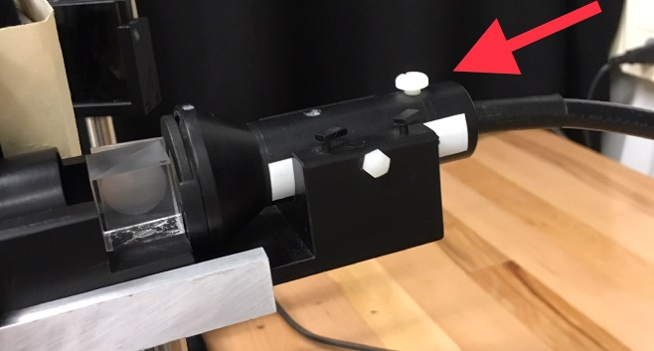

* + Once you pull the setup back, can remove the reticule and holder (in place with tiny pins) and replace with another reticule.

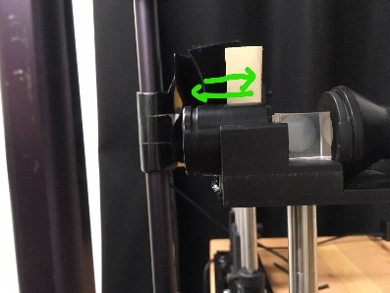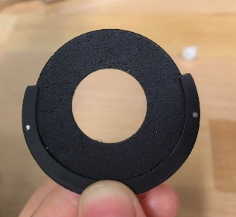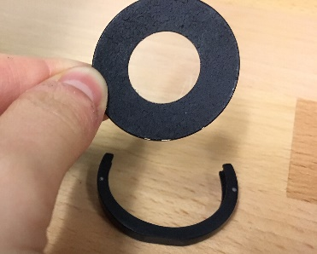

* setting up radiometer
  + Line up PR670 with eyepiece setup
  + Move focusing apparatus back and forth to bring the faint circle outline into focus
  + 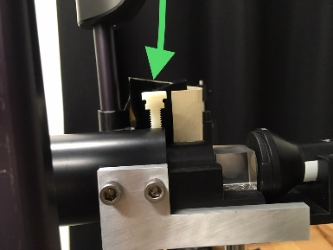Place barrel over the focusing assembly with its metal bar on the bottom. Then can screw in
  + Place the larger barrel over the smaller barrel and over the radiometer lens. Then slide in radiometer and screw parts together

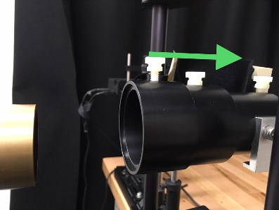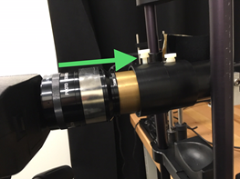

* + This makes sure the radiometer is always focused on the same part of the OneLight output
* Projector and filters
  + Meant to deal with issue where light goes out from OL, bounces off eye, bounces off central blocker and back to eye
  + The projector projects a tiny spot of light onto the blocker so the macula is light adapted
  + The brightness you need to project depends on the brightness of the light from the OneLight
  + To get desired brightness, can switch out filters
    - They are all log filters, so can add up logs to get total filtration
* Remote access for macbook
  + Apple🡪 system pref🡪 sharing
  + Under here, there is a URL for remote access. Can put this in screen sharing on another mac
  + Username is melanopsin, password is written on side of macbook
* Let the OneLight warm up for 3 hours before a subject comes in and uses it.